Unimog Tool Kit (Updated version)

Stock # | Item | Photo | Issue | Date | Date
 | Craftright 75 Piece Carry Case Tool Kit Bunnings $34.98  (Has many simple but useful bits) | 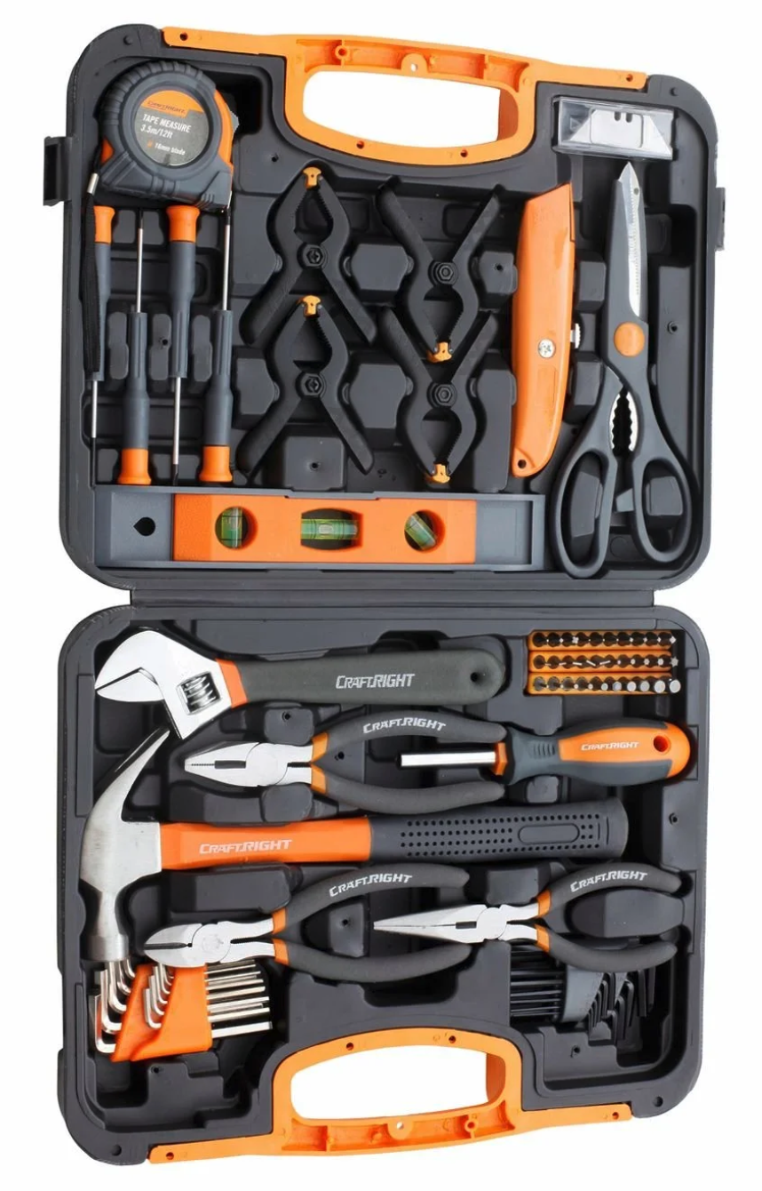 | 1
 | Ratchet Spanner Set  Total Tools for $269, ebay cheaper. Need a good kit of open and ring metric spanners (preferably ratchet) 8mm-24mm, 27mm, 30mm, 32mm. Most kits only go to about 20mm. Note need for 2 spanners of same size. | 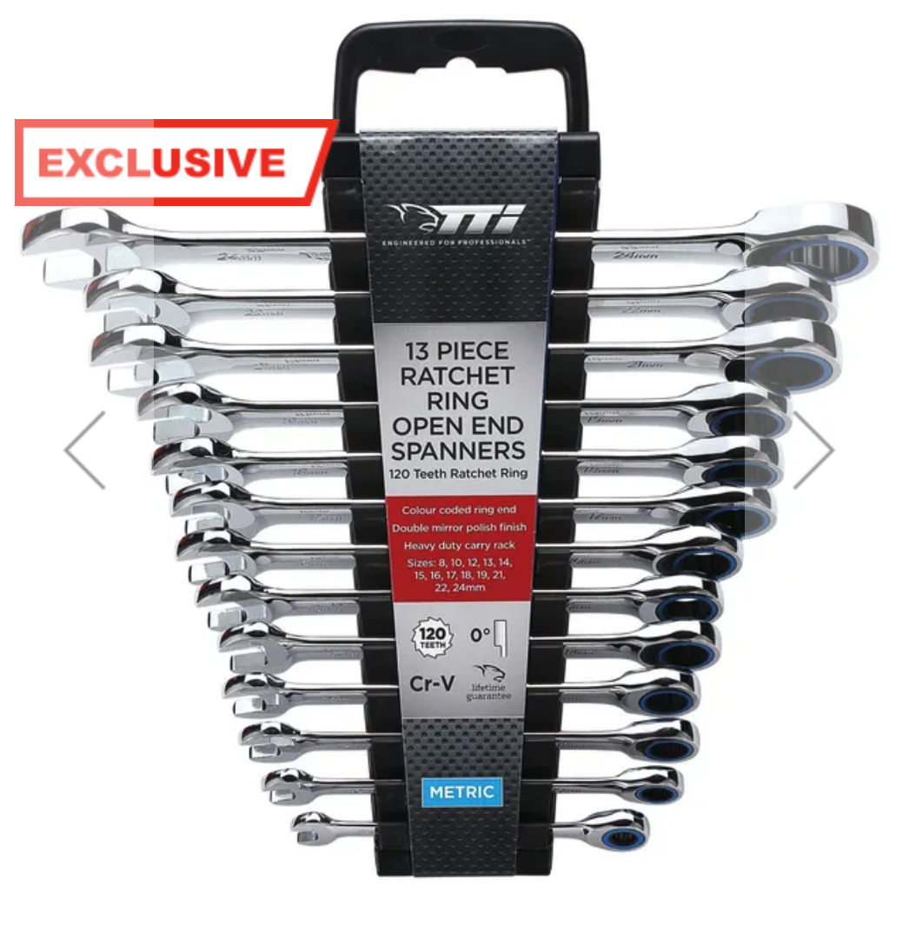 | 2
 | Socket kit. 8mm-24mm, 27mm, 30mm, 32mm. Most kits only go to about 20mm. ½ inch drive preferred.  NOTE: for things like wheel nuts, you need a torque wrench and any that I found that go to 400NM+ are ¾ inch drive – so large sockets in ¾ inch are recommended. I simply purchased the sizes I wanted in ‘TTI’ range at around $25 each. | 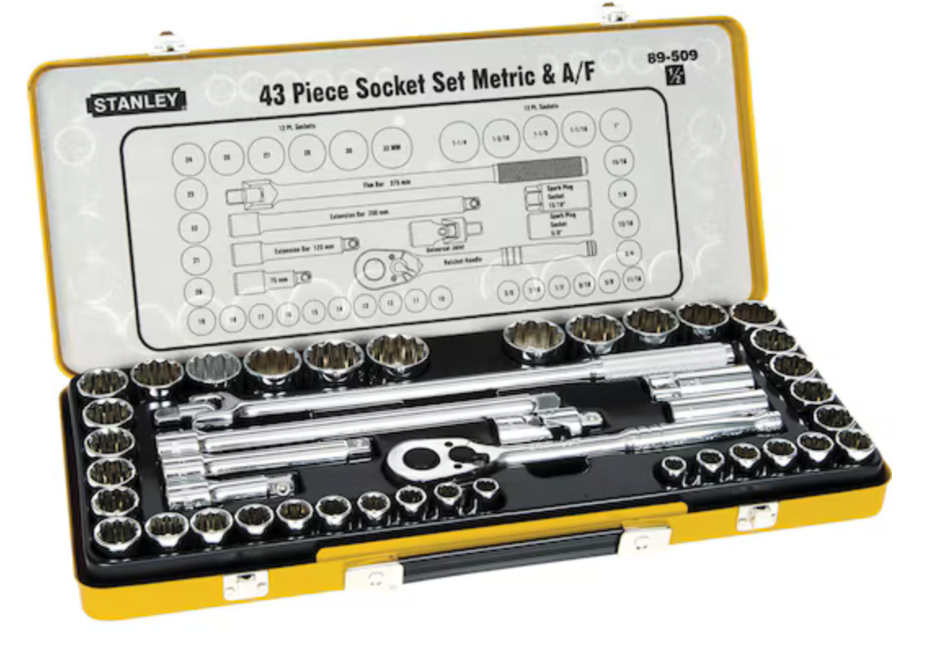
 | (Optional) Ratchet gun. Up to 1600NM. ½ inch or even better ¾. You can get a ½ to ¾ converter and vice versa.  I carry Ryobi batteries so this was as big as their range go. | 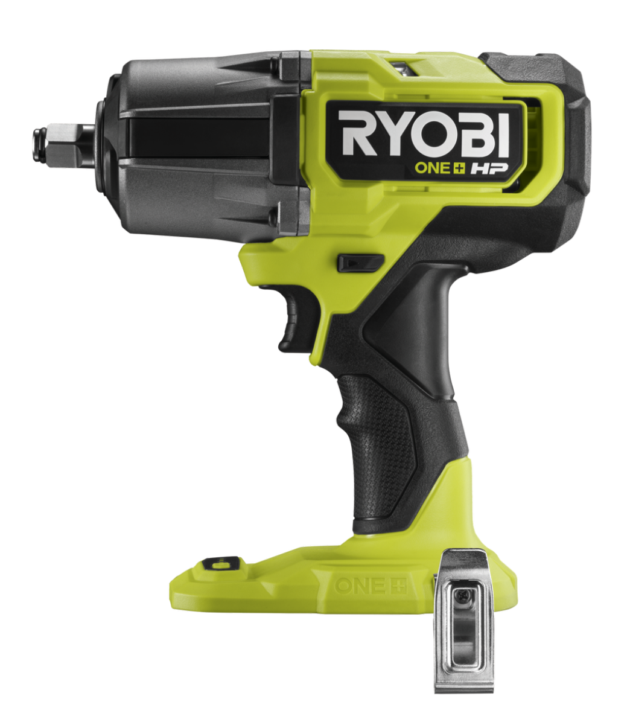
 | Recovery Kit | See webpage. MogCentral and George 4x4 do flavours. Need tree protector & dampener. Extension strap handy. | 1 +
 | Soft shackles & rings. The more the merrier. |  | X
 | Screwdriver Kit flat, Phillips, torqx. Brilliant 100 piece kit from Total Tools for $52.45 | 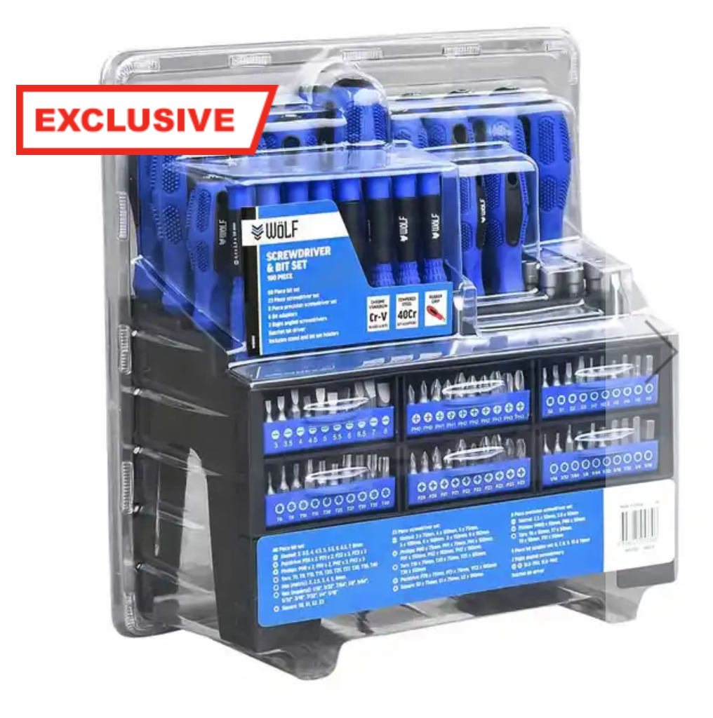 | 1
 | Axle stands (8000KG)  Total tool for $219 | 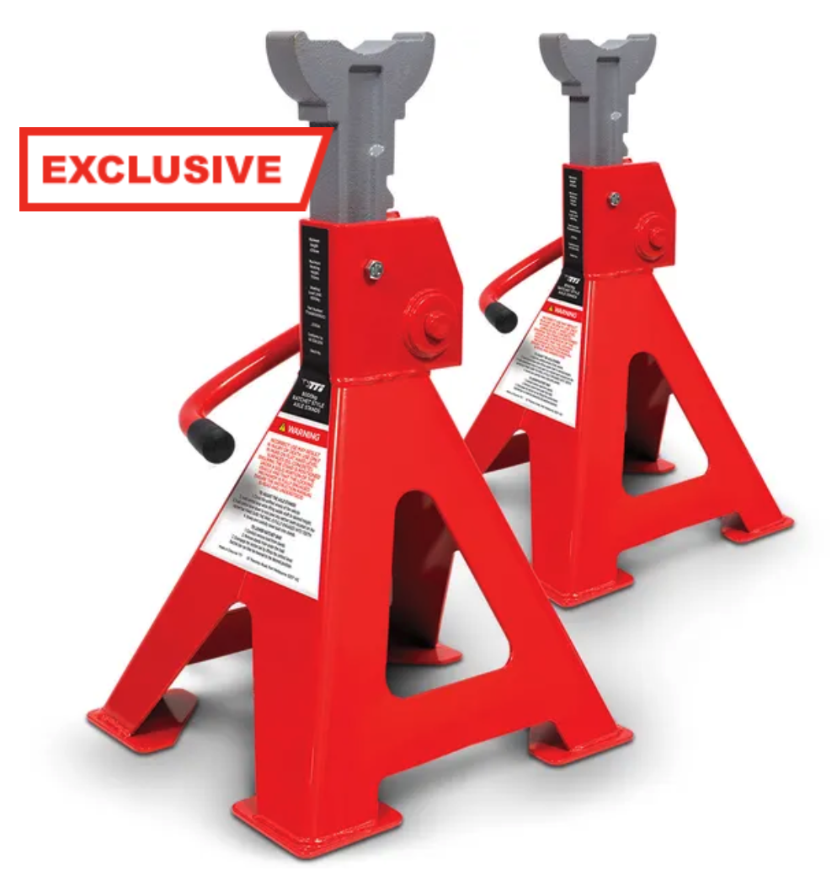 | 1
 | Glad Hand tyre inflation kit.  MogCentral $195.67 inc tax. Inflate any single tyre with this kit, or add multiple hoses to do multiple at once. (see next item below). | 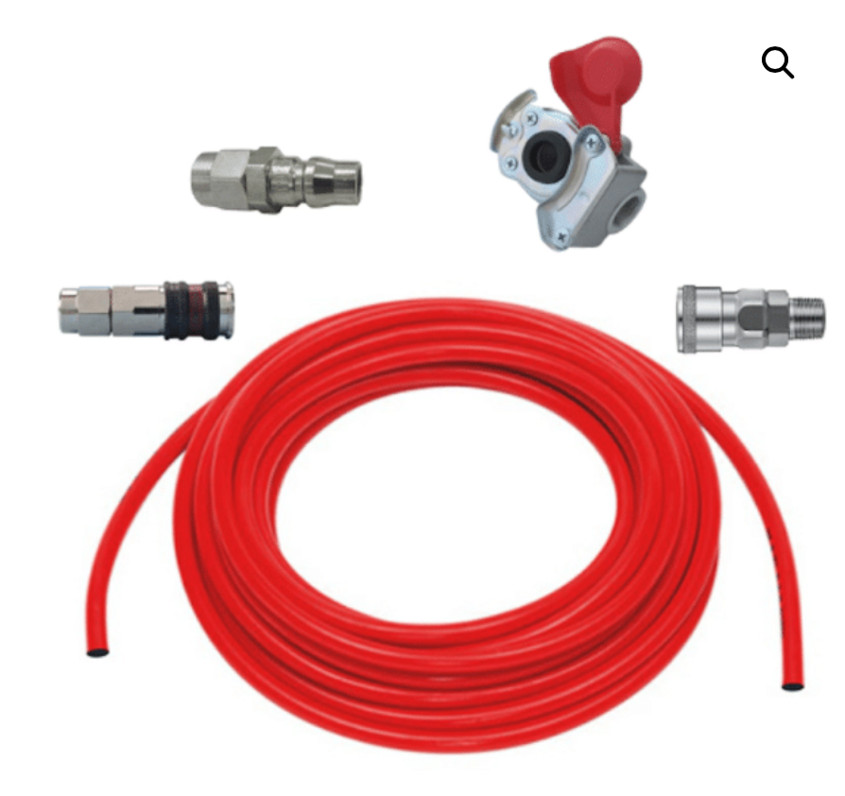 | 1
 | Tuff Terrain Multi Tyre Inflator Deflator Kit (4 Valve) $159.90 from outback equipment. This has two short legs and two long ones. It is able to go from one end of the Mog to the other and do all 4 tyres at once. | 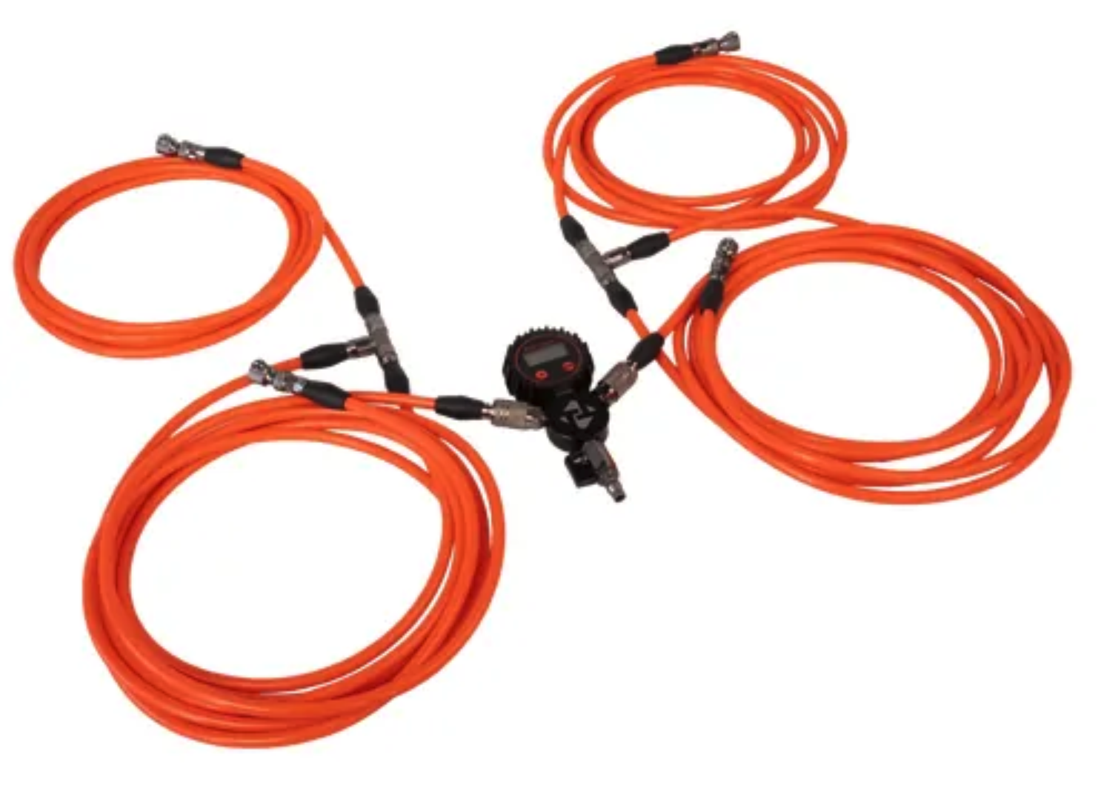
 | Torque Wrench (400NM or larger) Total Tools do a Warren & Brown ¾ inch Screen Torque Wrench that is 110-550NM. | 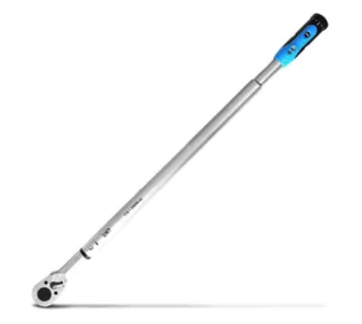
 | Adjustable Spanner (large). This covers off the large size nuts / bolts such as the 32mm. | 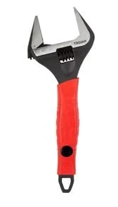 | 1
 | Grease gun & Grease | 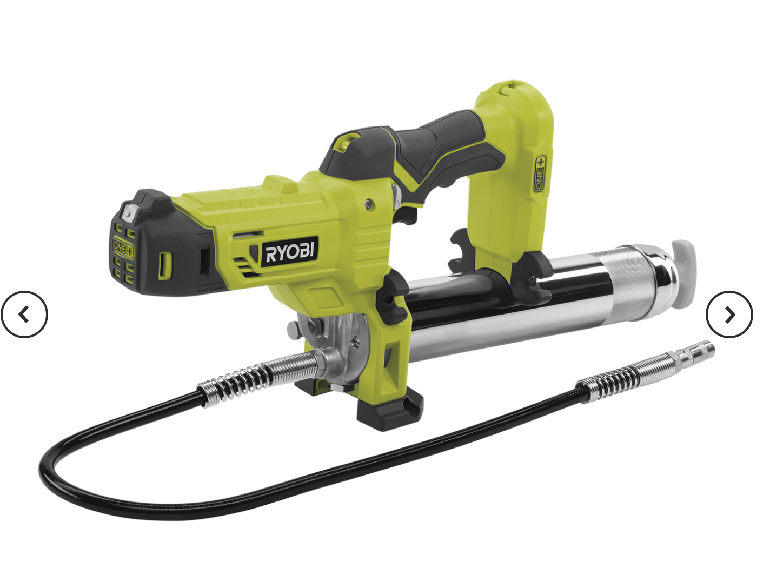 | 1
 | Rechargeable Torch. I know your phone can light things up, but not for far, or for long. A good wide-angle light with rechargeable battery is important. | 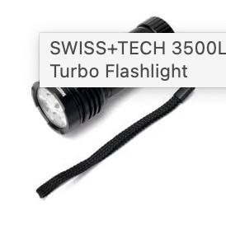 | 2
 | Headlamp. Just a cheap backup. | 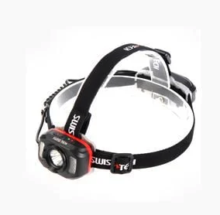 | 2
 | Water. I prefer the 10L plastic containers. Several of these avoid the problems of a breakage. | 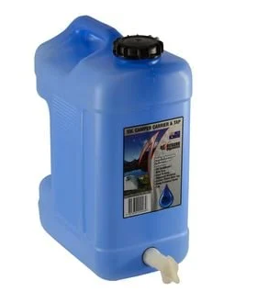 | 4
 | Fuel. Extra jerry can or two. | 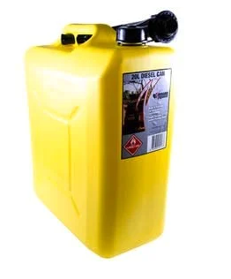 | 2
 | Electric chainsaw. Cheap, no need to carry fuel. Does the job. | 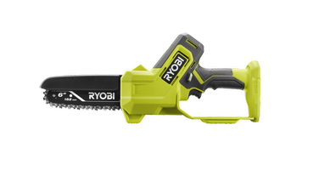 | 1
 | Hatchet / small axe. Still handy. Chop a branch or split fire wood. | 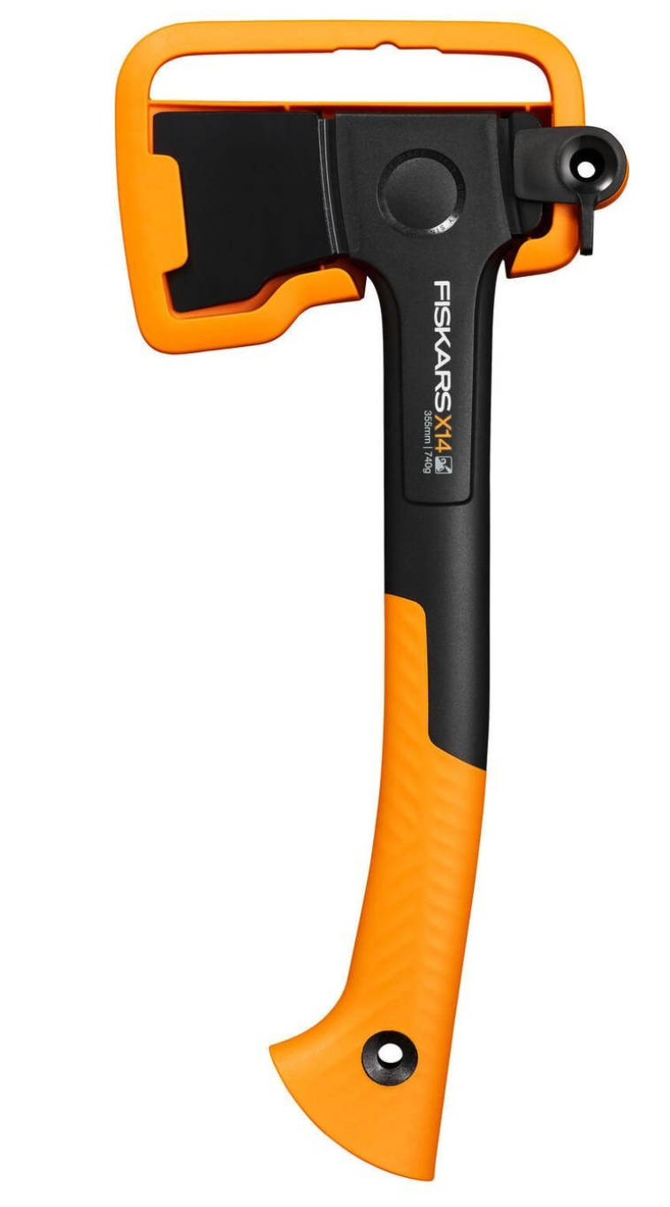 | 1
00-050-1229 | Valve core pneumatic tyre | 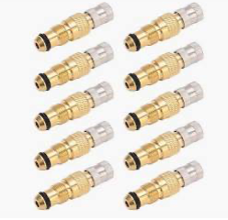 | 2
66-086-8464 | Chain assembly, single leg (no rating noted, but looks 6T +) | 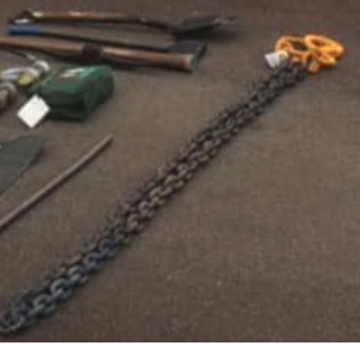 | 1
66-123-1452 | Shackle dee (again, no rating noted. Appear heavy duty) | 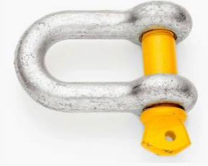  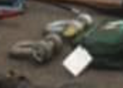 | 2
12-127-1254 | Hose, tyre inflation |  | 1
01-003- 9599 | Tyre pressure gauge | 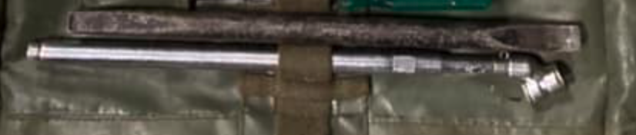 | 1
66-102-4283 | Lubricating gun | 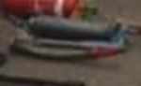 | 1
66-011-0377 | Axe, single bit, handle | 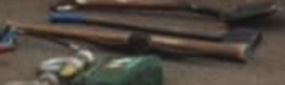 | 1
01-430-8166 | Wrench, boll & open end, 1.625inch 24.080 inches |  | 1
12-120-5'i99 | Wrench, open end 22mm &24mm |  | 1
66- 011-265t | Handle, wheel nut socket & remover | 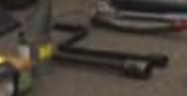 | 1
66-012-6821 | Handle, mattock- pick wood | 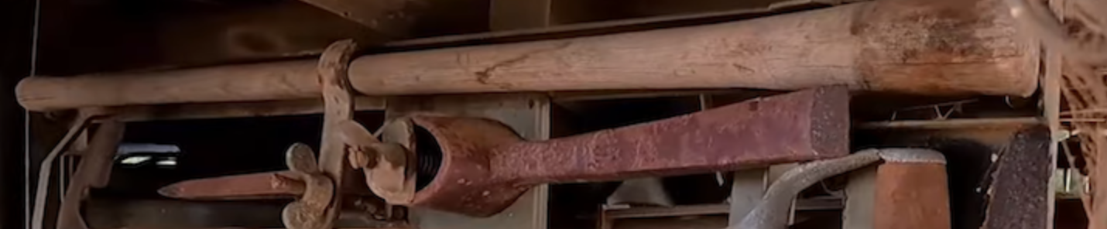 | 1
6-6-012-6893 | Pick, digging point & chisel ends |  | 1
66-013-0251 | Wrench, open end 10mm/11mm | 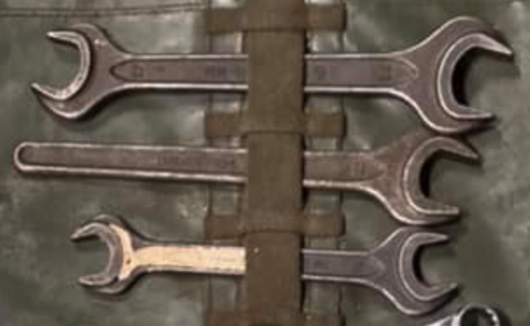 | 1
&3-013-0252 | Wrench, open end 14mm/15mm |  | 1
6 66-017-8438 | Wrench, open end 12mm/13mm |  | 1
66-017-8444 | Wrench open end 27mm/ 32mm |  | 1
66-017-8827 | Wrench box 16mm /17mm |  | 1
66-017-8828 | Wrench, box 18mm /19mm |  | 1
66-021-1613 | Key, socket head screw |  | 1
66-023-9517 | Combination pliers | 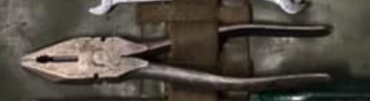 | 1
66-024-1402 | Hammer, hand ball pein |  | 1
66-024-7832 | Screwdriver, cross tip no.3 | 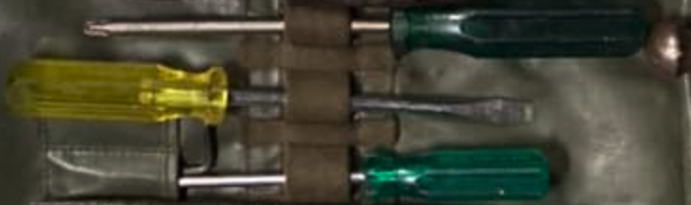 | 1
66-026-0206 | Screwdriver, flat tip 150mm |  | 1
66-027-2809 | Key, socket head screw 14mm L-type |  | 1
66-054-5253 | Wrench, open end 16mm/17mm |  | 1
66-093-8563 | Shovel, hand GS |  | 1
66-100-9355 | Wrench, open end 8mm / 9 mm |  | 1
66-100-9356 | Wrench, open end 18mm /19mm |  | 1
66-115-4530 | Screwdriver, cross tip no.2 |  | 1
66-067-5483 | Tools & accessories Roll | 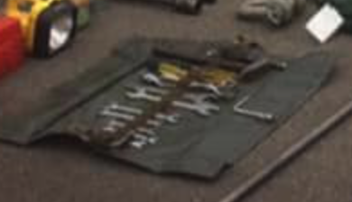 | 1
66-115-4524 | Wrench, open end 30mm |  | 1
66-115-4525 | Key, socket head screw straight, 17mm |  | 1
01-202-8113 | Battery, non rechargeable | I am guessing that this is one of those old massive 6v lantern batteries to suit the Dolphin Torch. | 1
66-027-6709 | Lantern, electric plastic case | 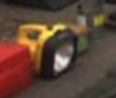 | 1
12-129-6156 | Lamp incandescent 24v |  | 1
12-173-5414 | Lamp incandescent transparent |  | 1
66-021-5710 | Can, dispensing funnel top,500ml |  | 1
66-054-8602 | Can, water plastic 22 LT | 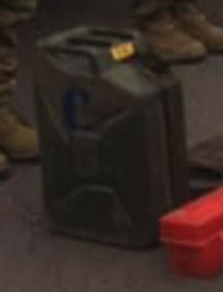 | 1
66�063-2338 | Filler neck assembly |  | 1
 | Ring, seating jerry can |  | 1
99-802-2405 | Can, jerrycan 20 LT |  | 1
66-016-0717 | Can, screw cap tin, 5 LT |  | 1
66-022-0114 | Box, small parts plastic |  | 1
66-118-6884 | Centre post |  | 2
66-118-6885 | right rear, Guard rail |  | 1
66-118-6886 | Front Guard rail, removable frame. |  | 2
66-118-6887 | Left rear, guard rail |  | 1
66-118-6888 | Tailgate |  | 1
66-118-6961 | Drop side assembly |  | 2
66-118-6962 | Drop side assembly |  | 2
66-117-4348 | Bow, middle |  | 1
66-118-4729 | support bow, veh top |  | 5
66-130-5098 | Bow, twist lock front |  | 1
66-130-5099 | Bow, twist lock, rear |  | 1
66-133-6525 | Seat assembly right hand side |  | 2
66-133-6526 | Seat assembly, left hand side |  | 2
66-147-5778 | Cover, fitted body |  | 1
66-133-6527. | Bracket, components front left hand |  | 1
66-133-6528 | Bracket, right hand front |  | 1
 | Fastener assembly, tumlock Ybow, rh front, LHrear |  | 2
66-130-5269 | Fastener assembly, tumlock Y bow, LH |  | 2
66-144-3223 | Rim, wheel, tyre, 3 piece rim |  | 1
12-159-8350 | Chock, wheel steel | 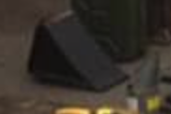 | 1
66-118-5747 | Inner tube, tyre, |  | 1
66-149-0654 | Tyre |  | 1
66-135-2640 | 1.5 kg, Extinguisher | 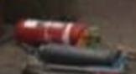 | 1
12-173-7140 | Bonnet locking, L type |  | 1
66-113-7917 | Jack, 10.000kg | 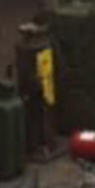 | 1
66-117-2503 | Jack base plate | 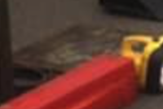 | 1
66-117-4334 | Wrench, socket wheel nut, 27mm /30mm |  | 1
66-122-8454 | Handle, hydraulic Jack 1000 kg | 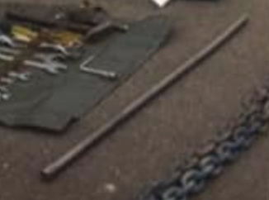 | 1
66-014-7365 | Padlock |  | 4
66-120-4919 | Crank handle |  | 1
66-122-7057 | Battery storage |  | 2
66-107-1001 | Book, record GM120 |  | 1
66-115-4721 | MANUAL, TECHNICAL |  | 1
66-145-7151 | Sign warning triangle set of 3 | 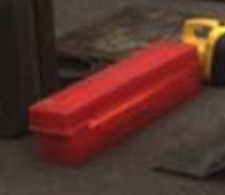 | 1

